## How does the Taobao e-commerce website work?

**Introduction:**

Technology is alternating our existence with its revolutionary speed and responsiveness. The e-commerce industry has expanded dramatically over the last 20 years. This is due to the growing consumer interest, engagement and elevated demand. Furthermore, Technology is the key force behind the growth and development of the e-commerce sectors B2B and B2C.[1]

China is the fastest growing and largest e-commerce market in the world, with around 632 million internet users.[2] Taobao is one of the biggest Chinese based e-commerce sites. In Chinese Taobao is written as 淘宝网 which is read as Táobǎo wǎng which literally translates to “seeking treasure online”. (Trade On Taobao, 2019) [3] . Moreover, Taobao is an e-commerce business owned by Alibaba, with the headquarter in Hangzhou, China. Alibaba Group funded the investment that established Taobao on May 10, 2003.

In addition, Taobao is an online marketplace where millions of entrepreneurs tap into China’s fast-growing consumer base. It is a Consumer-to-Consumer (C2C) and Business-to-Consumer (B2C) e-commerce marketplace that offers a platform for people and little business homeowners to sell their products online through their stores. Taobao is often referred to as the Chinese Amazon or eBay. However, Taobao outperforms Amazon and e-bay. Furthermore, it is the largest e-commerce website in the world and one of the world's top 10 most visited websites. Taobao is China’s largest market place by far with 800 million merchandise listed and over 500 million active users. Hence, it is the world’s biggest e-commerce website after amazon.[4]

In order to clearly understand how Taobao works, it is essential for us to look at the different components that make up Taobao. For this reason, the paper is sectioned into three main parts. The first section of the paper gives a brief explanation of what Taobao is; the second section of the paper mainly focuses on how Taobao works. Whereas the last section of the paper looks at how Taobao attracts its consumers.

**What is Taobao?**

Taobao is a preceding online shopping website founded in 2003 by Jack Ma's Alibaba Group. Taobao is a Chinese e-commerce website mainly developed for consumer-to-consumer retail. It supports young entrepreneurs and small enterprises to interact with customers from the Greater China Area, which incorporates Mainland China, Hong Kong, Macau and Taiwan. By 2010 Taobao was able to conquer the Chinese online shopping industry by about 80 per cent. Besides fixed priced goods, auctions led to a limited proportion of transactions.

The websites additionally enables buyer’s cross-research merchandise to help them make their purchasing decisions because it has the vendor’s information, remarks, complaints and ratings. One of Taobao 's dream is Chinese auto-empowerment and recognizing the desires of the Chinese customer.[5] Taobao is used by maximum Chinese and is developing variety of Asian and worldwide, customers. Taobao is one of the largest ecommerce sites in China, with over ten million sellers.[6] Taobao promotes the selling of cheap goods directly to customers.

**How does Taobao work?**

Taobao is composed of digital shops owned by people or companies. The retailer positions their goods or services on Taobao shop. Sellers on Taobao are capable to list their goods and services and sell them at the set rates or through auctions. Most of the products are a large variety of commodities that are priced at the set rates (like typical department stores). To assist customers, assess the goods and stores they look at product and save the seller info, reviews and rankings.

By using the Taobao search engine the customer searches for a specific commodity. When the customer has concerns, the customer contacts the store via the instant messaging program (Ali Wang Wang) offered by Taobao. After choosing a good, the consumer pays for the item using Alipay (the online and mobile payment network of Alibaba). The good is then placed in escrow (up to 10 days). The vendor is informed of the order and the items will then be delivered to the consumer. When the consumer receives the product, they have a short period to check if the item is in good condition and then the consumer will rate the product. The invoice would then be transferred into the shop from escrow.

During the year Taobao holds several online shopping festivals. The purpose of these festivals is to support the markets and sell more items. The most widely known is single’s Day or Double 11 which is conducted every year on the 11th of November. Along with paying scan, live streaming and other marketing tools, these festivals provide vendors with an incentive to advertise their goods and entice Chinese customers.

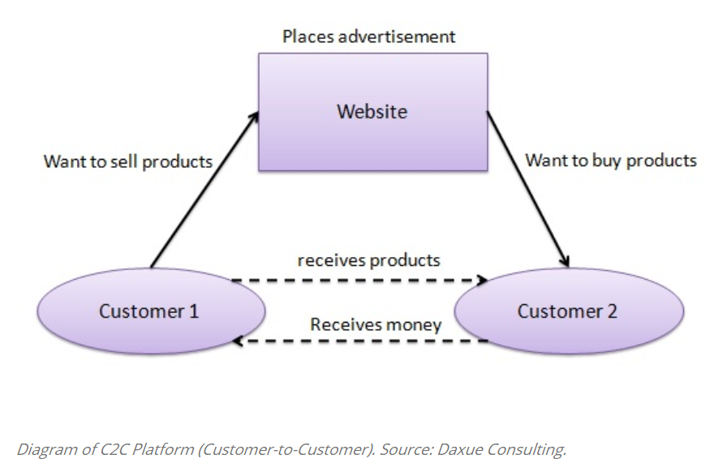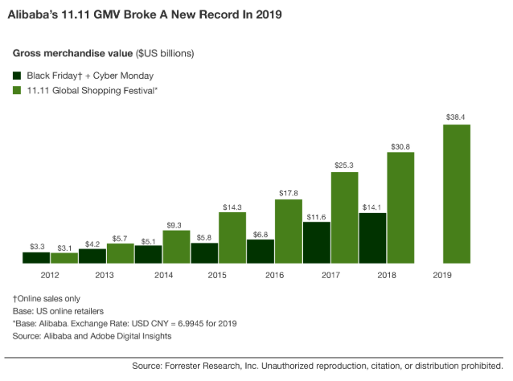

**Taobao Consumer Attraction:**

**Eye-catching website:**

Taobao being a popular online shopping platform offers users a feeling of anticipation. Taobao website features bright colors, smiling faces images, and innovative designs. Such features are rather appealing to consumers and thus tend to keep the attention of the customer. The software for the site is in Chinese, this allows them to condense their data into smaller spaces. The Chinese characters use up less space horizontally than English because they are denser. Hence, in a smaller horizontal room, they may stack more information to render the information less clustered. Sometimes, the user interface is well developed, helping consumers to switch quickly through topics that concern them the most.

**Items available for sale:**

Taobao is a major online shopping marketplace. It relies on several specific categories of goods to provide enough for nearly all kinds of customers. Consumers are granted the impression that on their site you can find anything that you like. Therefore, they can satisfy most customer demands and create the product brand itself. Although Taobao is known for its large product selection and aggressive pricing and is also known for hosting limited edition deals and unique items.

**Social media feed:**

The photos that trendy stars share on their social media on Taobao are becoming a significant part of the perception of Taobao material. Celebrities partner up with vendors on the Taobao site and in return, they choose their brand preferences rather than acting on behalf of other labels. This can be particularly successful in boosting revenue because it does not follow the conventional road to encouraging celebrities. Celebrities exhibit their preferences and customers seek to imitate their look to keep up with the new trends and designs.

**Hot Deals:**

Taobao sales continue to fuel customer curiosity around their online shopping. Consumers are obligated to respond rapidly by creating a sense of urgency with the offers. The fear of losing out on a fantastic commodity on an offer forces them to purchase. Taobao utilizes different expressions like "wow, what a bargain" instead of sales in order to attract the eye of the customers. In order to reinforce the urgency of an offer, there is also the use of a timer for different goods to show when the sale is over. Likewise, there is even a list of how many items were produced and how many exist. The maximum excessive deal is called “instant kill”, where extremely few units are available for an incredibly low price because of the massive discounts. Such sales typically last for a few hours, since the offers are so enticing that items sell out fast.

**Live Stream:**

The recent addition of a live stream has only improved then user comfort while shopping. A Taobao user can see live streams where KOLs and celebrities connect directly by showcasing the product’s capabilities. Such live streams also act as a bridge that influences the users in buying the object. Of certain featured items, after viewing the live stream to making a purchase needs just a few clicks that minimize friction throughout the buying phase. Hence, the KOLs / celebrities will also address any of the consumer's frequent concerns while watching their live stream, since there are discussion panels where they can interact with the streamer.

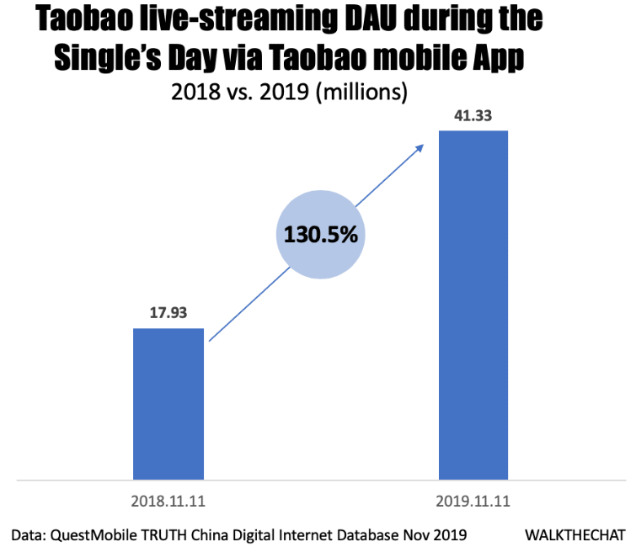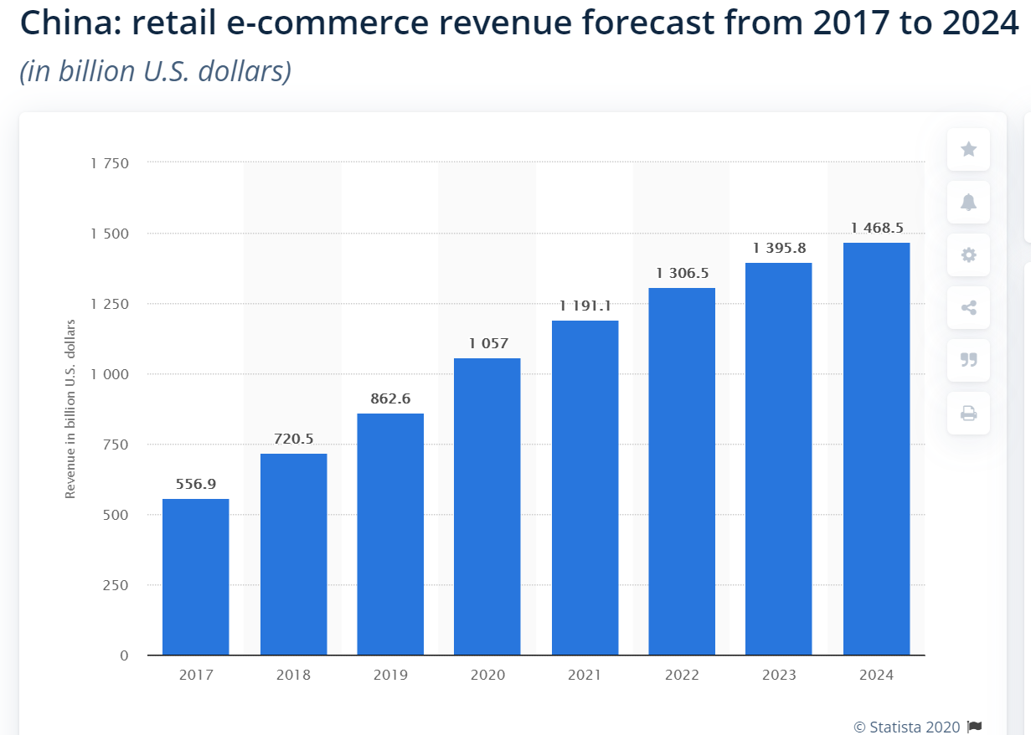

**Conclusion:**

This paper investigates how Taobao e-commerce operates. Furthermore, taking Taobao as an example the paper shows how the Chinese e-commerce industry has been one of the most established ones in the world. Hence, the paper provides details on what Taobao is and how it has been operating. In addition to that, through the study of its organization, marketing strategy, business model and, online payment system, the paper further exposes its positive experiences across numerous graphs that support the comprehension of this evolving e-commerce environment in China in general. Therefore, it is expected for Chinese e-commerce businesses like Taobao to grow more in the future which will lead to an increase revenue in overall.

**References:**

IndustryWired. "How Does Technology Impact on E-Commerce Industry?" *IndustryWired*. N.p., 06 Feb. 2019. Web. 01 Aug. 2020.

AsialinkBusiness. "E-Commerce in China." *Asialink Business*. N.p., n.d. Web. 01 Aug. 2020.

"What Is Taobao?" *Trade On Taobao*. N.p., n.d. Web. 29 July 2020.

Joson, Linjo, Aliakbar Panahi Says:, Linjojoson Says:, Maya Stickers Says:, Sarah Jay Says:, Harsh Nigam Says:, Bindeshwar Kush Says:, and John Max Says:. "Top 10 E-Commerce Sites in the World Based on Visitors-Updated List 2020." *GoMakeBig*. N.p., 10 May 2020. Web. 03 Aug. 2020.

DeGennaro, Tony. "What Are the 5 Aspects That Make Taobao a Leading Shopping Website?" *Dragon Social*. N.p., 08 Oct. 2019. Web. 02 Aug. 2020.

Manning, Aimee. "Selling In China: The Top Chinese Marketplaces To Sell On." *Linnworks*. N.p., n.d. Web. 03 Aug. 2020.

Zhang, Kaiyun,Li, Mingzhi, Tang, Yun , Chen, Guoqing, Reimers, Kai. "(PDF) Beyond Taobao.com: A Case Study on C2C Market in China." N.p., 1 Jan. 2007. Web. 2 Aug. 2020.

"Taobao Rising As The Number One E-commerce Platform in Hong Kong? - Pnetform Technology." *Web Design & Development Company in Hong Kong - Pnetform Technology*. N.p., 17 July 2019. Web. 03 Aug. 2020.

Baba, and Jameel Says:. "What Is Alibaba and How Does It Work? - StarBaba." *StartBaba*. N.p., 11 Oct. 2016. Web. 05 Aug. 2020.

Thibaud. "The Success of Taobao on the Chinese Internet - Daxue Consulting." *Daxue Consulting – Market Research China*. N.p., 02 Feb. 2018. Web. 06 Aug. 2020.

Chen, Tingyi. "2020 China Digital Marketing Trend." *WalktheChat*. N.p., 30 Dec. 2019. Web. 06 Aug. 2020.

Wang, Xiaofeng, and Alyson Clarke. "Three Key Factors That Drove Alibaba's 2019 Singles' Day Success." *Forrester*. N.p., 14 Nov. 2019. Web. 06 Aug. 2020.

Striapunina, Published by Ksenia, and Jun 8. "E-commerce Revenue in in China 2017-2024." Statista. N.p., 08 June 2020. Web. 07 Aug. 2020.

1. <https://industrywired.com/how-does-technology-impact-on-e-commerce-industry/>
2. <https://asialinkbusiness.com.au/china/sales-and-marketing/e-commerce-in-china?doNothing=1>
3. <http://tradeontaobao.com/what-is-taobao/>
4. <https://gomakebig.com/worlds-top-10-ecommerce-sites/>
5. <https://www.dragonsocial.net/blog/why-is-taobao-so-competitive-in-the-industry/>
6. <https://blog.linnworks.com/selling-in-china-marketplaces>